ContentGen - Generate high-quality blog content using AI

Description

The ContentGen is a modern web-based Content Management System (CMS) developed to make blog creation and content management easier and faster. It combines traditional blogging features with Artificial Intelligence (AI) to help users create useful and engaging content.The backend is developed using Node.js and Express.js, while MongoDB is used to store application data. Mongoose provides easy database management, data validation, and structured data handling.

The system integrates Google Gemini AI to provide intelligent features such as AI blog generation, FAQ generation, weather-based insights, and personalized fitness recommendations. These features help users generate content quickly with less manual effort.

ContentGen also provides strong security and user management. It uses JWT authentication for secure login sessions, role-based access control for different users such as Admin, Editor, Author, and Reader, and bcrypt.js for protecting passwords.

The system supports important CMS features including blog creation and editing, categories, tags, comments, media information, search functionality, input validation, rate limiting, and error handling. These features make the application secure, organized, and easy to maintain.

Overall, ContentGen is an AI-powered CMS that combines blogging, content management, and intelligent automation to provide a simple, efficient, and personalized content creation experience.

Scenario-Based Case Study

Background

Divya is a freelance writer who manages a technology blog and an educational website. She regularly publishes articles, tutorials, and product reviews, but handling content through spreadsheets and multiple applications has become difficult. As the number of contributor and readers increases, she needs a centralized platform to manage articles, user access, comments, media files, and AI-assisted content creation.

Problem

- Difficulty maintaining drafts, scheduled posts, and published articles in an organized manner.
- Problems managing categories and tags across multiple types of content.
- Delays in reviewing and approving articles submitted by authors.
- Manual effort required to moderate comments and remove inappropriate content.
- No dedicated system for managing uploaded images, documents, and related metadata.

Solution

The ContentHub backend provides a secure and centralized platform for managing digital content. It separates the backend services from the frontend and supports different user roles. The system handles article publishing, content categories, media files, user permissions, and comments efficiently.

Usage
- Author Usage: Authors can create and edit blog posts, save drafts, upload media, organize content, and view the performance of their posts.
- Editor/Admin Usage: Editors and administrators can review submitted posts, approve or update publishing status, manage comments, and control user permissions.
- Reader Usage: Readers can view published blogs, search for content, and submit comments.

Outcome

The BlogNest system provides a well-organized and reliable platform for managing blog content and user activities. By bringing content creation, scheduling, media management, comments, and user permissions into one centralized backend, it reduces manual work and improves the overall workflow.
The system makes content management faster and more organized. It reduces manual work, improves security through role-based access, and helps maintain accurate content and user information. It also makes the platform easier to manage and expand in the future.

Software Requirements

  - Operating System: Windows 10/11, macOS, or Linux can be used as the development platform.

  - Node.js: Node.js is required to execute the backend JavaScript code and manage the server-side environment.

  - NPM: NPM is used to install, update, and manage the different packages and dependencies required by the project.

  - Express.js: Express.js provides the framework for creating server routes, handling client requests, and developing REST APIs.

  - MongoDB: MongoDB is used as the database for storing user information, blog posts, comments, categories, and other application data.

  - Postman: Postman is used to test API requests and verify whether the backend services are working correctly.

Hardware Requirements

  - Processor: An Intel Core i5 or AMD Ryzen 5 processor or equivalent is recommended for smooth development.

  - RAM: A minimum of 8 GB RAM is required. 16 GB RAM is preferable when running the database, code editor, browser, and server simultaneously.

  - Storage: At least 10 GB of free storage is recommended for the project files, development tools, database, and supporting packages.

  - Display: A standard HD display is sufficient for coding and testing the application.

  - Internet Connection: A stable internet connection is required for downloading packages, accessing development resources, and testing web services.

Epic:-1 PROJECT ARCHITECTURE

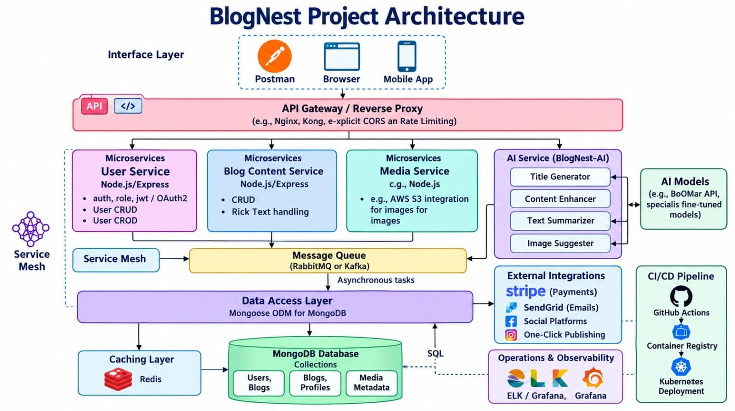

The BlogNest application exposes structured endpoints handled by a layered server architecture model. Incoming requests undergo filter processing before interacting with data services.

Components Definition

  - Interface: API tools like Postman query distinct route paths to extract JSON entities.
  - Express Server Gateway: Monitors network ports, maps explicit HTTP methods (GET, POST, PUT, DELETE), parses JSON payloads, and handles CORS headers.
  - Authentication & Role Matrix Middleware: Extracts tokens from headers, validates user context signatures, and evaluates if the specific role satisfies authorization thresholds for guarded resource paths.

  - Granular Services (Logic Modules): Enforces isolated domain rules for blog lifecycles (Draft, Pending Approval, Scheduled, Published), comment queues, and system reporting indicators.

  - Database Interface Layer: Mongoose translates operational application logic into performant native MongoDB queries.

  - AI Flow (Service Integration): Provides intelligent content automation, including automated blog post generation and real-time content summarization. This layer connects to external AI models via specialized endpoints (/api/ai/generate-blog and
/api/ai/summarize), allowing the controller layer to offload complex text processing tasks and enhance content creation workflows.

  - BlogGenerator with AI: A specialized service that automates the generation of blog content, which integrates with the AI Flow service to streamline the drafting process.

Entity-Relationship (ER) Diagram Description

The underlying document structure manages several collections bound by logical application references:

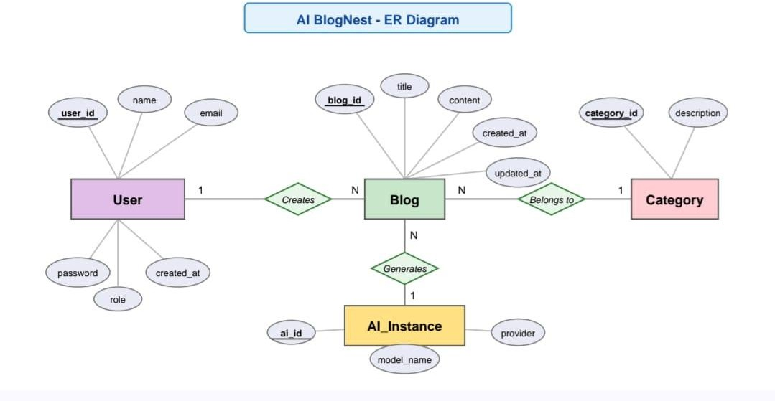

User Entity

  - _id (Unique ID for each user)
  - name (Name of the User)
  - email (User’s email address)
  - password (Login Password)
  - role (User role in the system)

Post Entity

  - _id ( A unique identifier automatically assigned to each blog post)

- userID ( References the user who created or owns the post)

- name (Stores the title of the blog post and is a required field)

  - photo ( Contains image information or file path associated with the post)

  - message ( Stores the main written content of the blog)

  - likes ( Records the number of likes received by the post, with a default value of zero)

  - timestamps ( Automatically maintains the post creation and last update dates)

Key Structural Mappings

User to Post (One-to-Many): An author can submit multiple blog documents.

User to Comment (One-to-Many): Readers/Users can append multiple response comments across independent post nodes.

Post to Comment (One-to-Many): A single blog document stores individual referenced comment submissions.

Key Features

    - Role-Based Route Guarding: Controls access to different pages or features based on the user’s assigned role. It prevents unauthorized users from accessing or modifying restricted settings.
    - CRUD Blog Execution Engine: Manages the main blogoperationCreate,Read,Update, and Delete (CRUD)—for blog posts, content, status, and related assets.
    - Categorization System:Organizes blog posts using tags or categories, making it easier to filter, search, and find relevant content.
    - Comment Moderation Logic:Manages comments by checking and updating their status, such as approved, pending, or spam, to keep the blog safe and organized.
    - Sanitization Safeguards: Payload parameter sanitation prevents XSS vectors and NoSQL parameter manipulation injections.
    - I-Driven Blog Generation Pipeline: Integrates external Large Language Model (LLM) abstractions and context-aware prompt templates to synthesize full-length, structured blog posts from high-level thematic inputs.
    - Intelligent Content Summarization Engine: Leverages semantic compression layers to parse extensive article payloads, dynamically generating concise abstracts and automated metadata

Roles and Responsibilities

    - Admin: Complete environment override control. Can manage user database registrations, alter role assignments, prune malicious comments, and inspect full logging entries.
    - Editor: Focuses on editorial workflows. Reviews pending draft posts, marks records for instant publication, and handles category cleanup scripts.
    - Author: Restricted account access. Can issue creation statements only for posts bound to their explicit account record.

    - Reader: Consumer access profile. Reads published materials and posts comments under an ongoing authenticated identity.

User Flow:

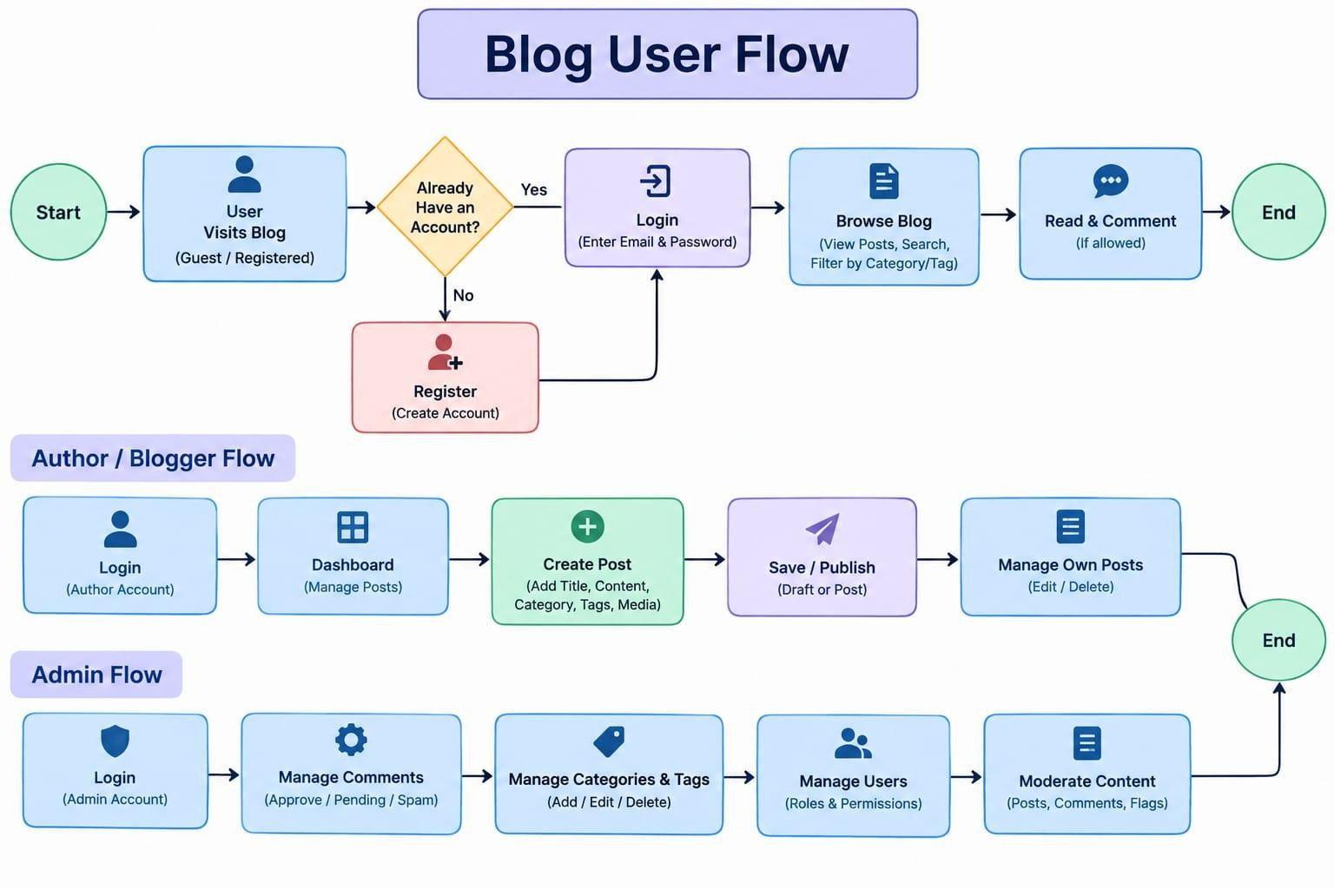

MVC Architecture Pattern

The system architecture structures its source configuration layers around the Model-View-Controller design pattern to completely decouple components:

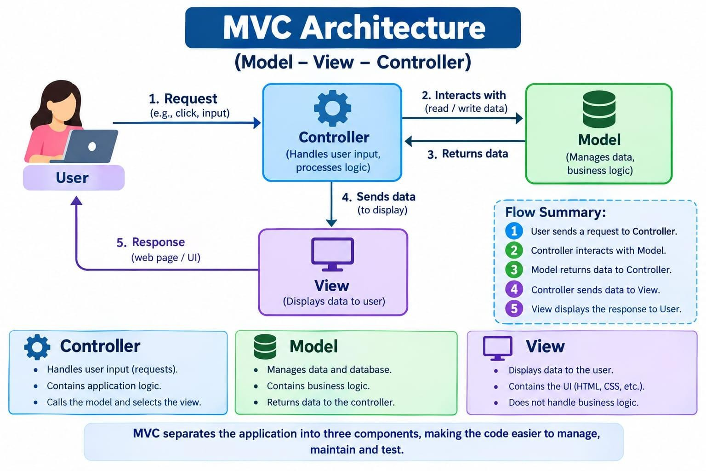

Model Layer (Data Blueprint)
Defines structure blueprints via strongly enforced Mongoose schemas mapping explicit fields into raw collection items inside MongoDB. It sets default states, indexing rules, and transformation parameters before validation persistence occurs.

Controller Layer (Execution Matrix)
The intermediary brain of the ecosystem. It captures request vectors from the execution routes, checks structural request constraints, delegates processing workflows directly to models, and packages the resultant output into standard JSON return arrays.

View Layer (Routing Network Interface)

In this pure headless backend service context, standard user-interface template views do not exist. Instead, the interface layer lives as an API Routing Layer. It links network requests on specified paths directly to their associated controller handler logic maps.

Epic2: Project Setup and Configuration

Creating project folder
- Create a new folder with your <project name>.
- Inside that folder create one new folders.

- Name another one as Server.

- Now open that folder in VS Code.

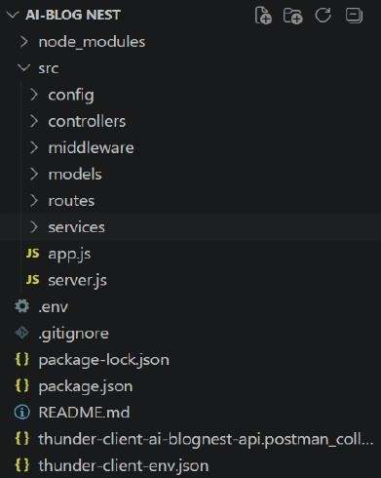

Server setup (npm init)
  - Open Server folder in terminal of VScode.
- npm init -y
  - Create files:
- server.js
  - Create folders
- models
- controllers
- routes

Epic 3: Backend Development

Server.js
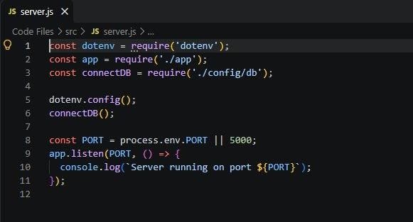

App.js
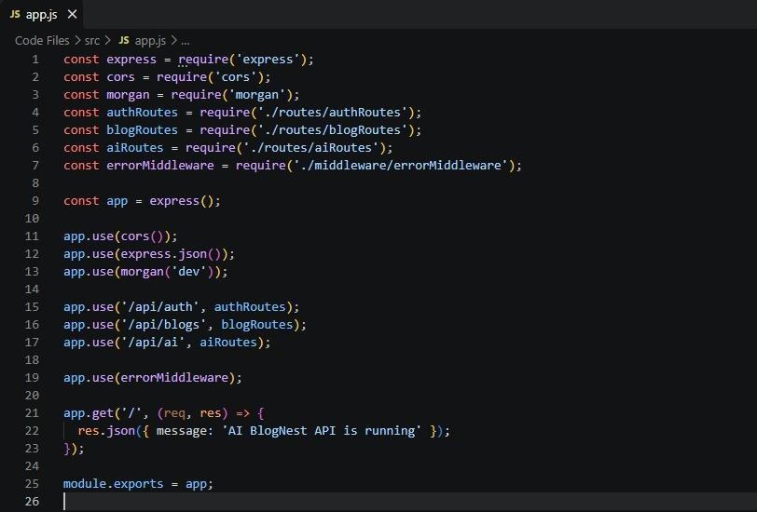

Epic4: Database Configuration

DB connection:-
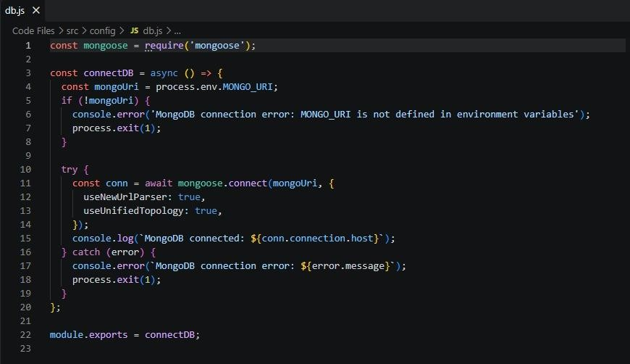

Configure MongoDB:
  - Install Mongoose.
In your Node.js project directory, run:
npm install mongoose
- Create database connection.
- Create Schemas & Models.

Create Database connection:
Now, make sure the database is connected before performing any of the actions through the backend. The connection code looks similar to the one provided below

Mongoose Schema Definitions

- Identity Resource Document Schema (schemas/userModel.js)
Enforces field criteria validations on incoming database creations.

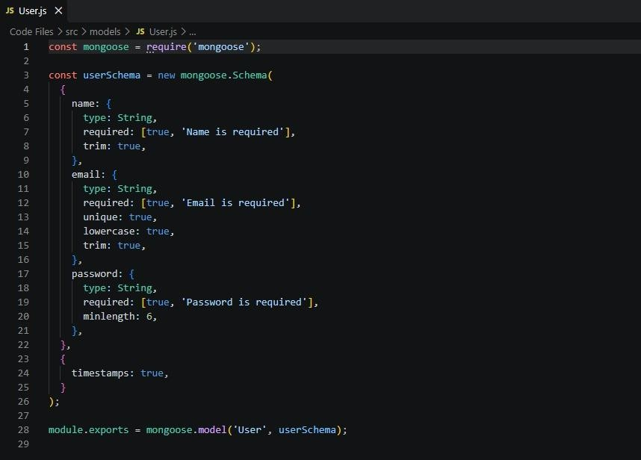

Epic 5: Project Executions:
  - Install Postman or ThunderClient (VS Code extension).

  - Start the backend server:
“npm start”

API Testing

User Registration :-
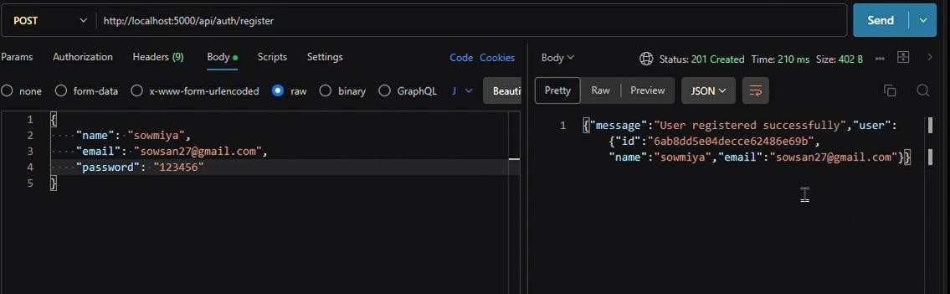

User Login:-
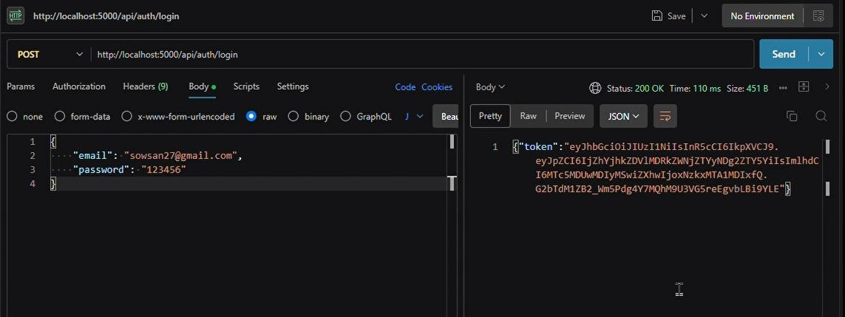

Create Blogs :-
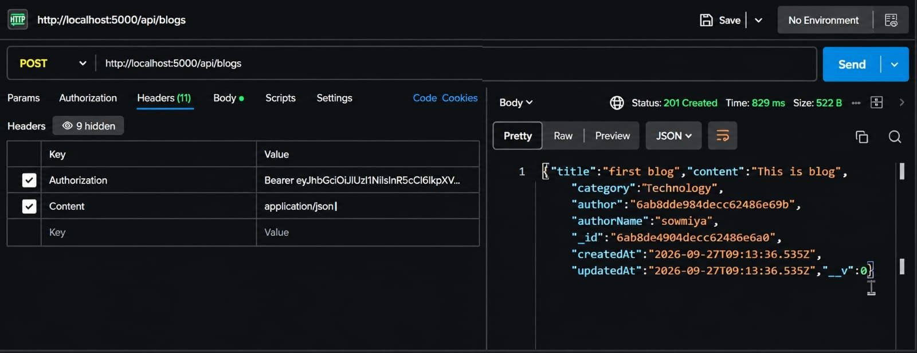

Fetch Blogs :-
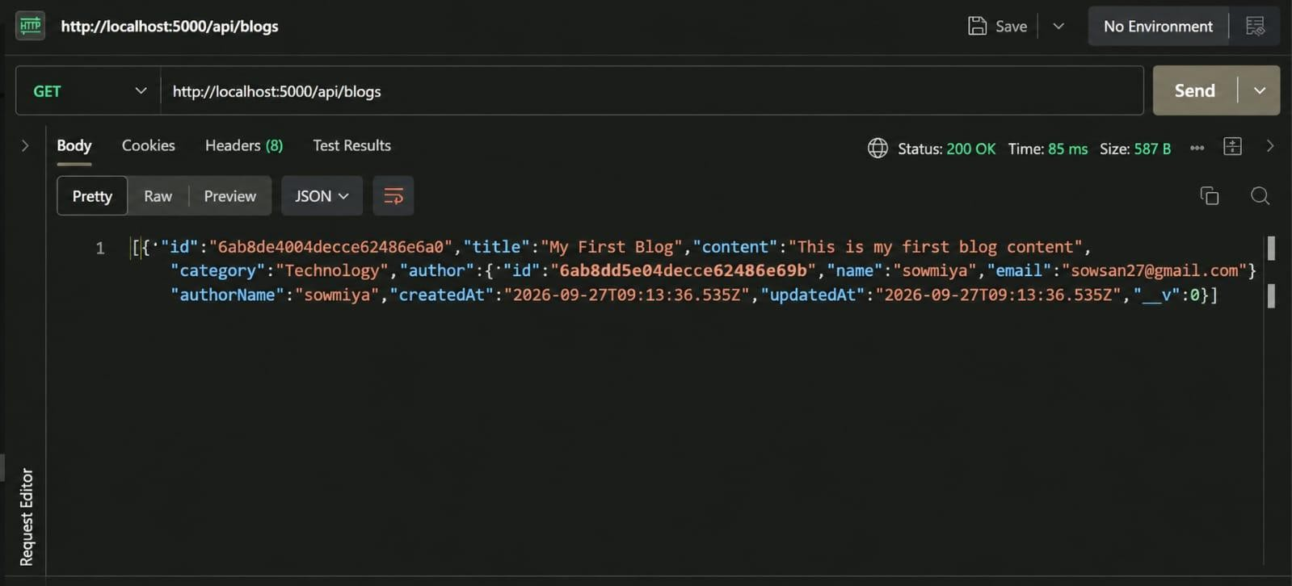

Generate AI blogs :-
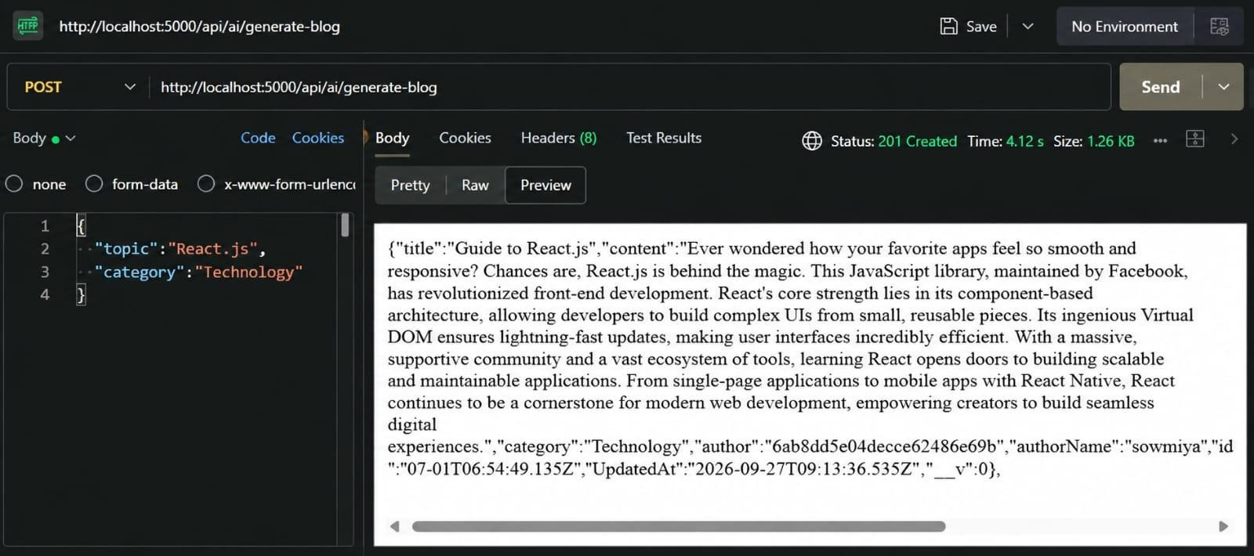
Summarize Blogs :

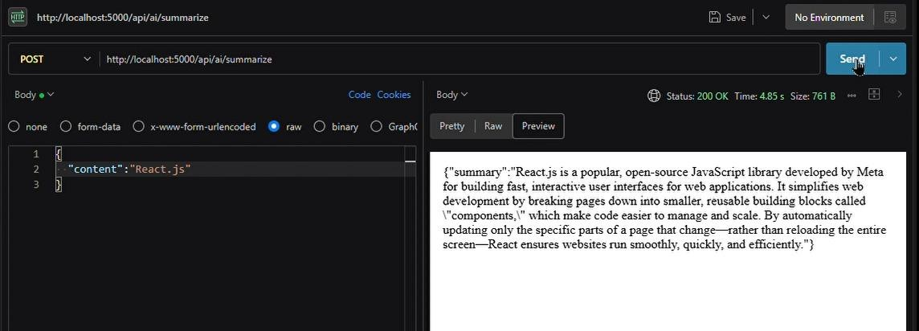

Demo Video: View Demo Video
API testing video: View API Testing Video
Code: View Source Code

